Lecture 1

Introduction to Java.

- Java :- Java is a Open-source, high-level, object-oriented, platform-independent programming language used to build applications of all types web, mobile, desktop, cloud, and enterprise systems.

- Created by Sun Microsystems in 1990 (now owned by Oracle).

Comparing Java with Other Programming Languages.

- Stability , Compatibility , Scalability , Agility , Reliability , Versatility , Cross-Platform Development , Scalability and Robustness , Security

Introduction to JDK.
- The JDK(Java Development Kit) is a software development environment that is used to write , compile and run java program.

Introduction to JRE & JVM.
- JRE allows Java programs to run.
- JVM executes Java bytecode and makes the platform independent.

Introduction to IDE (Integrated Development Environment)
- An IDE (Integrated Development Environment) is a software application that provides tools to help programmers write, test, and debug code efficiently.

EX. Intellij IDEA , Eclipse , NetBeans
First Java Program.

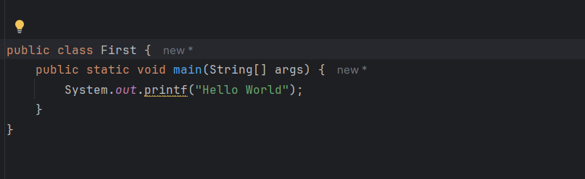

How to run a Java Program using terminal / CMD.

- First run javac filename.java
To compile a java file and create filename.class file.

- Then run java filename
To execute or run java code.

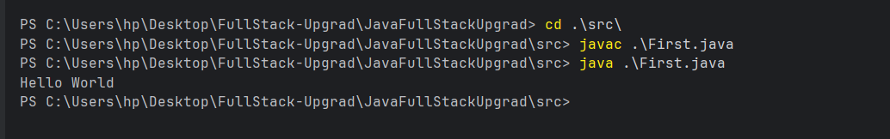

Lecture:-2

Variable :- Variable is a name storage location in your computer memory that holds a value.

Data type:- Data types classify the type of data a variable can hold.They determine the kind of data stored and operations permitted on that data.

Ex :- Int , String , Boolean , double , long
Type of data type.

- Primitive data type:-Primitive data types are basic data types in Java used to store simple values like numerical and character data.

The data stored in a primitive data type can be changed after it is declared and initialized.
Ex:- int , float , double ,long ,boolen,char

- Non-Primitive / Reference data types :-Non-primitive data types (also called Reference types) are complex data types in Java used to store the memory address (reference) to an object. They are often created from the composition of primitive types.

The data stored in a non-primitive data type can not change after it is declared and initialized.

Ex:- String , Array(int[],String[]), Classes (e.g Car , Scanner), Interfaces, and Enums.

Data type size:- int (4bytes), long (8bytes) ,float (4bytes),
double(8bytes), char(2bytes), short(2bytes)

In case of Non-Primitive (Reference) Data Types Size is determined dynamically.
Practice Question

●Declare and initialize variables to store information about a student (name, age, grade) and print them.

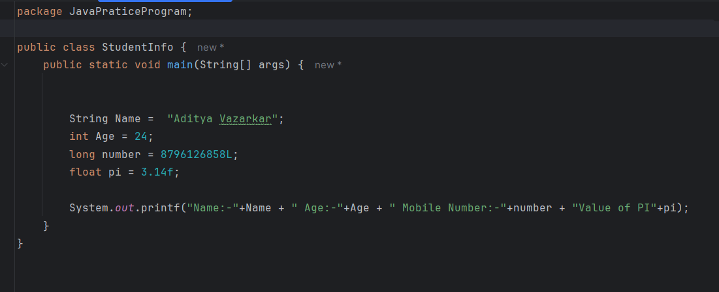

- You're developing a simple student information system in Java. Your program should allow users to input and store information about students, including their names, ages, grades, and favorite subjects. Design the program and declare the necessary variables to implement this functionality.
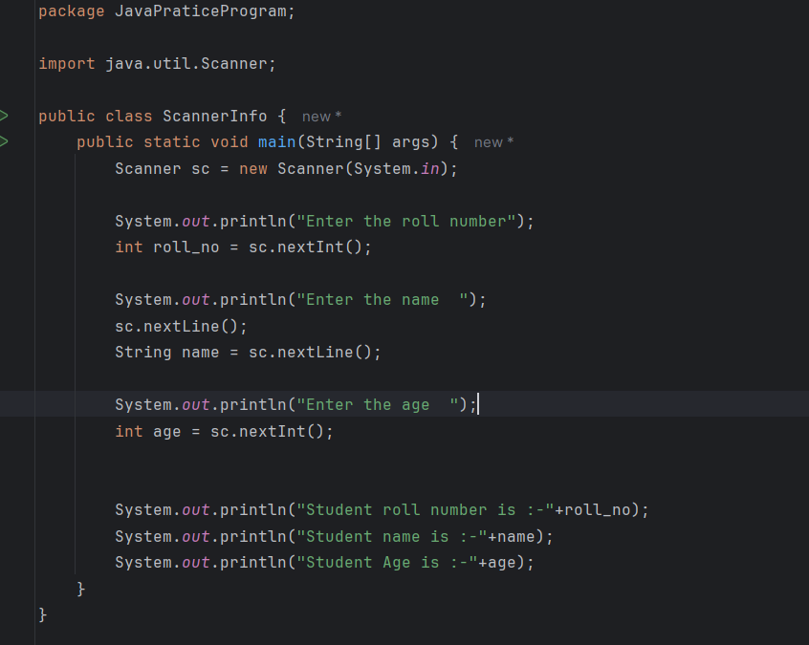

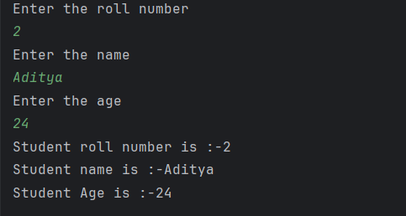

- Write code for take input from command line without Scanner class

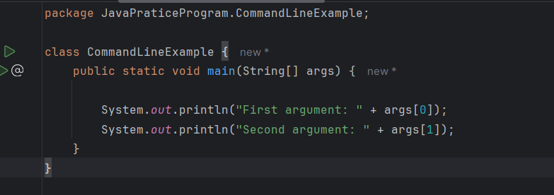

- What is use of public static void main(String[] args)
public static void main is the starting point of a Java program, which is called by the JVM to begin program execution.

Public:- Makes the method accessible from anywhere
Static:- Allows JVM to call main() class without creating an object.

Void:- Means no return value.

Main:-fixed name.

String[] args:- user take input from commend line
Lecture : 3

Java Operators:
Operators in Java are special symbols used to perform operations on variables and values.

Arithmetic Operators(+ - * / %)
Used for mathematical calculations.
int a = 10, b = 3;
System.out.println(a + b); // 13
System.out.println(a - b); // 3
System.out.println(a * b); // 30
System.out.println(a / b); // 3
System.out.println(a % b); // 1

Relational (Comparison) Operators(== , !=,>,<,>=,<=)
Used to compare two values.
int a = 10, b = 3;
System.out.println(a > b); // true
System.out.println(a < b); // false
System.out.println(a == b); // false
System.out.println(a != b); // true
System.out.println(a >= b); // false
System.out.println(a <= b); // false

Logical Operators(&& , ||)
Used with boolean values.

boolean x = true, y = false;
System.out.println(x && y); // false
System.out.println(x || y); // true

Post Increment(i++):-Post increment means the value is used first, then it is increased by 1.
int x = 5;
System.out.println(x++); // 5
System.out.println(x); // 6

Pre Increment(+ii):-Pre increment means the value increased by 1 first then value is used;
int x = 5;
System.out.println(++x); // 6
System.out.println(x); // 6

Lecture : 4
Control flow statement

1] Conditional statement / Decision-making

Conditional statements are used to make decisions in a program based on conditions (true / false).

I]if statement:-Executes code only if the condition is true.

Ex:-
int age = 18;

if (age >= 18) {
System.out.println("Eligible to vote");
}

II]if-else statement:-Executes code when if condition is false.

Ex:-
int num = 5;

if (num % 2 == 0) {
System.out.println("Even number");
} else {
System.out.println("Odd number");
}

III] if-else-if Ladder:- Used for multiple conditions.

Ex:-

int marks = 75;

if (marks >= 90) {
System.out.println("Grade A");
} else if (marks >= 60) {
System.out.println("Grade B");
} else if (marks >= 40) {
System.out.println("Grade C");
} else {
System.out.println("Fail");
}

IV]switch Statement:-Use switch when you compare one variable with many constant values.

Ex:-
char grade = 'A';

switch (grade) {
case 'A':
System.out.println("Excellent");
break;
case 'B':
System.out.println("Good");
break;
case 'C':
System.out.println("Average");
break;
default:
System.out.println("Fail");
}

2] Looping Statement:-
Looping statements are used to repeat a block of code until a condition is satisfied.

I]for Loop:-Used when the number of iterations is known.

for(int i = 1; i <= 5; i++) {
System.out.println(i);
}
Output:
1 2 3 4 5

II]while Loop:-Used when the number of iterations is not known in advance.

int i = 1;
while(i <= 5) {
System.out.println(i);
i++;
}
Output:
1 2 3 4 5

III]do-while Loop:-Executes the loop at least once, even if the condition is false.

int i = 1;
do {
System.out.println(i);
i++;
} while(i <= 5);

Output:
1 2 3 4 5

IV]break:-use to exit the loop immediately.
for(int i = 1; i <= 5; i++) {
if(i == 3) break;
System.out.println(i);
}
Output:
1 2

V]continue:-use to skip the current iteration.

for(int i = 1; i <= 5; i++) {
if(i == 3) continue;
System.out.println(i);
}

Output:
1 2 4 5

Lecture : 5
Java Date Format:-
Java provides two main ways to handle date formatting:

1] Java.time package(java 8+)

import java.time.LocalDate;
import java.time.format.DateTimeFormatter;

public class Main {
public static void main(String[] args) {

LocalDate date = LocalDate.now();

DateTimeFormatter formatter = DateTimeFormatter.ofPattern("dd-MM-yyyy");

String formattedDate = date.format(formatter);
System.out.println(formattedDate);
}
}

Output:-
26-12-2025

Common Date Format Patterns

Pattern | Meaning | Example
dd | Day | 26
MM | Month | 12
yyyy | Year | 2025
yy | Year(2 digit) | 25
MMM | Month name | Dec
MMMM | Full month | December
HH | Hour (24) | 18
hh | Hour (12) | 06
mm | Minutes | 45
ss | Seconds | 30

String dateStr = "25-11-2024";
DateTimeFormatter formatter = DateTimeFormatter.ofPattern("dd-MM-yyyy");

LocalDate date = LocalDate.parse(dateStr, formatter);
System.out.println(date);

Lecture : 6
String in Java: A string is an object that represents a sequence of characters.
String is immutable, meaning once created they cannot be changed.

There are two ways to create a string.
1]String name = “Aditya”;
2]String s2 = new String(“Hello”);

String Method:
1]length(): Return the total number of characters in the string.

String s = "Java";
System.out.println(s.length());

Output:
4

2]toUpperCase():Convert all characters to uppercase.

String s = "java";
System.out.println(s.toUpperCase());

Output:
JAVA

3]toLowerCase():Convert all characters to lowercase.

String s = "JAVA";
System.out.println(s.toLowerCase());

Output:
java

4]charAT(int index):Returns the character at specific index (index starts from 0).

String s = "Java";
System.out.println(s.charAt(1));

Output:
a

5]substring(): Extracts a part of the string.

String s = "Programming";
System.out.println(s.substring(0, 6));

Output
Progra

6]equals(): Compares content of two strings (case-sensitive).
String a = "Java";
String b = "Java";

System.out.println(a.equals(b));

Output
True

7]replace(): Replaces one character or string with another.

String s = "Java";
System.out.println(s.replace('a', 'o'));

Output
Jovo

String Pool: The String Pool (also called String Constant Pool) is a special memory area in the Heap where Java stores string literals to save memory.

Example 1:
String s1 = "Java";
String s2 = "Java";

System.out.println(s1 == s2);

Output:
True

Reason:- Both s1 and s2 point to the same object in the String pool.Point to same memory location.

Example 2:
String s3 = new String("Java");

System.out.println(s1 == s3);
System.out.println(s1.equals(s3));

Output:
False
True

First give false because new String() creates a new object in the heap, not in the string pool.

Second give true because the .equals method checks the value instead of memory location.

Array in Java: An array in Java is a collection of elements of the same data type stored in contiguous memory locations.

Why Use Arrays?
- Store multiple values in one variable.
- Easy access using index.
- Improves code readability.

Declaration of Array:
1]int[] arr;
2]arr = new int[4];
3]int[] array = new int[4];

Array with Values
int[] numbers = {10, 20, 30, 40, 50};

1]Accessing Array Elements:
Using indexing access the element.

System.out.println(numbers[0]); // 10
System.out.println(numbers[3]); // 40

2]Updating Array Elements:
numbers[2] = 100;

Output
10, 20, 100, 40, 50

3]Array length:
System.out.println(numbers.lenght);//5

Array methods in java:

1]length:Returns the size of the array.
int[] arr = {10, 20, 30};
System.out.println(arr.length);
Output:
3

2]Arrays.toString():Converts array to readable string format.
import java.util.Arrays;

int[] arr = {1, 2, 3};
System.out.println(Arrays.toString(arr));
Output:
[1, 2, 3]

3]Arrays.sort():Sorts the array in ascending order.
int[] arr = {5, 2, 8, 1};
Arrays.sort(arr);
System.out.println(Arrays.toString(arr));

Output:
[1, 2, 5, 8]

4]Arrays.equals():Compares two arrays element by element.

int[] a = {1, 2, 3};
int[] b = {1, 2, 3};

System.out.println(Arrays.equals(a, b));

Output: true

package JavaPraticeProgram.CommandLineExample.Lecture6;

import java.io.*;
import java.util.*;

public class Solution {

public static void main(String[] args) {

Scanner sc=new Scanner(System.in);
String A=sc.next();
String B=sc.next();
/* Enter your code here. Print output to STDOUT. */

System.out.println(A.length()+B.length());
System.out.println(A.compareTo(B) > 0?"Yes":"No");
System.out.println(A.substring(0,1).toUpperCase()+A.substring(1,A.length())+" "+B.substring(0,1).toUpperCase()+B.substring(1,B.length() ));
}
}

Output:

Hello
World
10
No
Hello World

package JavaPraticeProgram.CommandLineExample.Lecture7;

import java.util.Arrays;

public class AddiditionOfArray {
public static void main(String[] args) {
int[] numbers = {1,2,3,4,5};
int [] numbers1 = {6,7,8,9,10,11,12,13,14,15};
int size;
int[] result;
if(numbers1.length > numbers.length) {
size = numbers.length;
result = numbers1;
} else {
size = numbers1.length;
result = numbers;
} for(int i = 0; i < size; i++) {
result[i] = numbers1[i] + numbers[i];
}
// System.out.println(Arrays.equals(result, numbers1));
System.out.println(Arrays.toString(result));
System.out.println(Arrays.toString(numbers1));
System.out.println(numbers1.equals(result));
}

}

Output:
[7, 9, 11, 13, 15, 11, 12, 13, 14, 15]
[7, 9, 11, 13, 15, 11, 12, 13, 14, 15]
true

Lecture: 7
Function:In java function also called method.
A method/function is a block of reusable code that performs a specific task and run only when it called.

How to create function:

public int addition(int a , int b){

}

Ex
package JavaPraticeProgram.CommandLineExample.Lecture8;
public class Addition {

public void add(int a , int b){
int sum = a+b;
System.out.println(sum);
}
}

ackage JavaPraticeProgram.CommandLineExample.Lecture8;

public class Main {
public static void main(String[] args) {
Addition ad = new Addition();
ad.add(15,6);

}
}

Output:
21

Static function: A static function in Java is a method that belongs to the class, not to an object.
We can not access the static method by using object.
To call static method by using class name.
package JavaPraticeProgram.CommandLineExample.Lecture8;

public class StaticMethod {
public static void Hello(){
System.out.println("Hello");
}
}

package JavaPraticeProgram.CommandLineExample.Lecture8;

public class Main {
public static void main(String[] args) {
StaticMethod.Hello();

}
}

Output
Hello

Non-Static function:
Called using objects.

package JavaPraticeProgram.CommandLineExample.Lecture8;

public class Non_Static_Method {

public void Hello(){
System.out.println("Hello");
}

}

package JavaPraticeProgram.CommandLineExample.Lecture8;

public class Main {
public static void main(String[] args) {
Non_Static_Method non_static_method = new Non_Static_Method();
non_static_method.Hello();

}
}

Lecture 8:
Object Oriented Programming Language:

4 Pillars Of Object Oriented Programming Language:
- Encapsulation
- Inheritance
- Polymorphism
- Abstraction

1.Encapsulation:
Encapsulation is a pillar of a object oriented programming language.Data can be kept hidden and private within a class without letting the outside world direct access.

Ex:-
class Bank {
private double balance;

public void setBalance(double bal) {
balance = bal;
}

public double getBalance() {
return balance;
}
}

2.Inheritance:
Class can build on top of extent class and extend their capabilities inherit the properties and method.They Have a Parent Class And Child Class.This Concept promote the code reuse,modularity,and customization,enhanceing,the overall design,and maintain ability of software system.

Ex:
class Animal {
void eat() {
System.out.println("Eating...");
}
}

class Dog extends Animal {
void bark() {
System.out.println("Barking...");
}
}

3.Polymorphism:
Poly means Many
Morphism means forms.
It Perform the task in many form.

There have two methods in polymorphism
- Overriding:It have a Same Parameter
- Overloading:It Have a different parameter.

Method Overloading (Compile-time)
class Add {
int sum(int a, int b) {
return a + b;
}

double sum(double a, double b) {
return a + b;
}
}

Method Overriding (Runtime)
class Parent {
void show() {
System.out.println("Parent class");
}
}

class Child extends Parent {
void show() {
System.out.println("Child class");
}
}

4.Abstraction:
Abstraction refer to the methods or the interface that a class exposes to access data and feature from the outside world.

a]Abstract Class
abstract class Vehicle {
abstract void start();
}

class Car extends Vehicle {
void start() {
System.out.println("Car starts with key");
}
}

b] Interface
interface Payment {
void pay();
}

class UPI implements Payment {
public void pay() {
System.out.println("Payment via UPI");
}
}

Access Modifiers:
- Public
- Private
- Protected
- Default

1.Public Access Modifiers:
Public Access Modifiers is the most permissive access level.members with public access are accessible from any others class or package.

2.Private Access Modifiers:
Private access modifiers restricts access to members within the same class.members marked as private cannot be accessed from outside the class.

3.Protected Access Modifiers:
Protected Access Modifiers allows access to members within the same package and same sub classes.
Members marked as a protected are accessible within the same package and by same classes

4.Default Access Modifiers:
Default Access Modifiers also known as package private,restricts access to members within the same package.members marked as a default are not accessible from class outside the package.

DSA

Lecture 9: Array List
An ArrayList is a resizable array in Java.
It is part of the Collection Framework and is used when you need:
- Dynamic size (can grow/shrink)
- Fast access using index(get(i))

Declare arrayList:
import java.util.ArrayList;
ArrayList<Integer> arr = new ArrayList<>();

Methods in array list.
1]add(value):- Add element in array list.
2]add(index , value):-Add element particular position.
3]get(index):- show element at that index.
4]set(index , value):- update element particular index.
5]remove(index):- delete element at that index.
6]remove(object):- delete by value.
7]size():- Number of elements.
8]contains(value):- check value present in list.
9]isEmpty():- check if the array is empty or not.
package JavaPraticeProgram.CommandLineExample.DSA.ArrayList;
import java.util.ArrayList;
public class ArrayListImp {
public static void main(String[] args) {
ArrayList<Integer> list = new ArrayList<>();

list.add(10);
list.add(20);
list.add(30);

System.out.println(list); // [10, 20, 30]
System.out.println(list.get(1)); // 20

list.set(1, 25);
list.remove(0);

System.out.println(list); // [25, 30]
System.out.println(list.size()); // 2
}
}

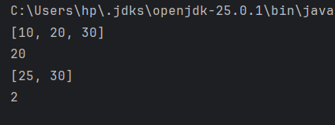

Lecture 10: Linked List

A Linked List is a collection of nodes where:
- Each node stores data
- And a reference to the next node
Elements are not stored in continuous memory like array.

package JavaPraticeProgram.CommandLineExample.DSA.LinkList;
public class LinkedListFirstProgram {
Node head;
class Node {
int data;
Node next;
Node(int data){
this.data = data;
this.next = null;
}
}
//Add First
public void addFirst(int data){
Node newNode = new Node(data);
if(head==null){
head =newNode;
return;
}
newNode.next = head;
head = newNode;
}
//Add Last
public void addLast(int data){
Node newNode = new Node(data);
if(head == null){
head = newNode;
return;
}
Node currentNode = head;
while (currentNode.next != null){
currentNode = currentNode.next;
}
currentNode.next = newNode;
}
//Add Anyposition
public void Anypostion(int element , int key){
Node newNode = new Node(element);
if(head == null){
System.out.println("List is empty");
return;
}
Node currentNode = head;
while (currentNode != null && currentNode.data != key){
currentNode = currentNode.next;
}
if(currentNode == null){
System.out.println("Key not found");
return;
}
newNode.next = currentNode.next;
currentNode.next = newNode;
}
//delete first
public void deleteFirst(){
if(head == null){
System.out.println("List is empty");
return;
}
head = head.next;
}
//delete Last
public void deleteLast(){
if(head==null){
System.out.println("List is empty");
return;
}
if(head.next == null){
head=null;
return;
}
Node secondLastNode = head;
Node lastNode = head.next;
while (lastNode.next != null){
lastNode = lastNode.next;
secondLastNode = secondLastNode.next;
}
secondLastNode.next = null;
}
//delete any position
public void deleteAtAnyPosition(int key){
if(head == null){
System.out.println("List is empty");
return;
}
Node currentNode = head;
while (currentNode != null && currentNode.next.data != key){
currentNode = currentNode.next;
}
if(currentNode.next == null){
System.out.println("Key not found");
return;
}
currentNode.next = currentNode.next.next;
}
// Display
public void display(){
if(head==null){
System.out.println("List is empty");
}
Node currentNode = head;
while (currentNode != null){
System.out.print(currentNode.data+"->");
currentNode = currentNode.next;
}
System.out.println("Null");
}
}

package JavaPraticeProgram.CommandLineExample.DSA.LinkList;
public class Main {
public static void main(String[] args) {
LinkedListFirstProgram linkedListFirstProgram = new LinkedListFirstProgram();
linkedListFirstProgram.addFirst(20);
linkedListFirstProgram.addFirst(30);
linkedListFirstProgram.addFirst(40);
linkedListFirstProgram.display();
linkedListFirstProgram.addLast(50);
linkedListFirstProgram.display();
linkedListFirstProgram.deleteFirst();
linkedListFirstProgram.display();
linkedListFirstProgram.deleteLast();
linkedListFirstProgram.display();
linkedListFirstProgram.Anypostion(60,30);
linkedListFirstProgram.display();
linkedListFirstProgram.deleteAtAnyPosition(20);
linkedListFirstProgram.display();
}
}

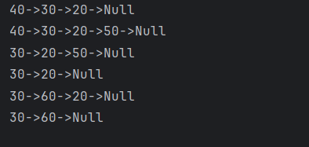

Linked list using collection:Java already provides a ready-made Linked List class inside the Collection Framework, so you don’t need to create Node,head.

import java.util.LinkedList;
LinkedList<Integer> list = new LinkedList<>();

Method:
1]add():- Add element to linked list.
2]addFirst():- Add element to start.
3]addLst():- Add element to last.
4]remove():- Remove element from first.
5]removeFirst():-Remove element from first.
6]removeLast():-Remove element from last.
7]get():- Access by index.
8]set():- update element.
9]contains():-search element.
10]size():- count element list.
11]clear():- delete all elements.
12]isEmpty():- check empty or not.

package JavaPraticeProgram.CommandLineExample.DSA.LinkList;

import java.util.LinkedList;

public class LinkedlistCollection {
public static void main(String[] args) {
LinkedList<Integer> list = new LinkedList<>();

list.addFirst( 50);
list.addFirst(60);
list.addLast(70);
list.addLast(80);
System.out.println(list);

list.removeFirst();
System.out.println(list);
list.removeLast();
System.out.println(list);

System.out.println(list.get(1));

list.set(1,90);
System.out.println(list);

}
}

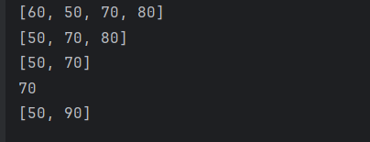

Lecture 11: Stack

Stack is a linear data structure which follows the LIFO manager.
LIFO(Lest In First Out).

Stack implement using Array.
package JavaPraticeProgram.CommandLineExample.DSA.Stack.StackUsingArray;

public class StackUsingArray {

int size;
int top;
int[] stack;

StackUsingArray(int size){
this.size = size;
stack = new int[size];
top = -1;
}

void Push(int data){
if(top == size-1){
System.out.println("Stack Overflow");
return;
}
stack[++top] = data;
System.out.println(data+" Pushed");
}

void Pop(){
if(top == -1){
System.out.println("Stack is empty");
return;
}
System.out.println(stack[top--]+"Popped");
}

void Peek(){
if(top == -1){
System.out.println("Stack is empty");
return;
}
System.out.println("Top element is "+stack[top]);
}

void Display(){
if(top == -1){
System.out.println("Stack is empty");
return;
}
for(int i= top;i>=0;i--){
System.out.print(stack[i]+" ");
}
System.out.println();
}

}

package JavaPraticeProgram.CommandLineExample.DSA.Stack.StackUsingArray;

public class ImpStackUsingArray {
public static void main(String[] args) {
StackUsingArray stackUsingArray = new StackUsingArray(5);

stackUsingArray.Display();

stackUsingArray.Push(10);
stackUsingArray.Push(20);
stackUsingArray.Push(30);
stackUsingArray.Display();

stackUsingArray.Pop();
stackUsingArray.Display();

stackUsingArray.Peek();
stackUsingArray.Display();
}
}

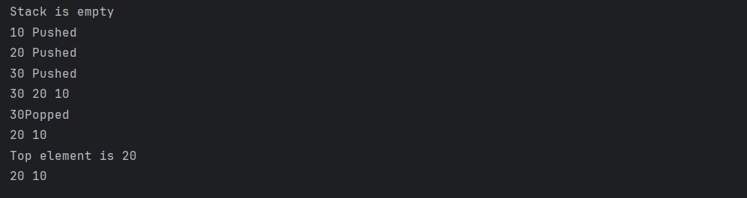

Stack using Linked List.
package JavaPraticeProgram.CommandLineExample.DSA.Stack.StackUsingLinkedLest;
class Node{
int data;
Node next;

Node(int data){
this.data = data;
this.next = null;
}
}
public class StackUsingLinkedList {
Node top;

void Push(int data){
Node newNode = new Node(data);

newNode.next = top;
top = newNode;
System.out.println(data+"Pushed");
}

void Pop(){
if(top == null){
System.out.println("Stack is underflow");
return;
}
System.out.println(top.data+"Popped");
top = top.next;
}

void Peek(){
if(top == null){
System.out.println("Stack is empty");
return;
}
System.out.println("Top element is:- "+top.data);
}

void Display(){
if(top == null){
System.out.println("Stack is empty");
return;
}
Node temp = top;
while (temp != null){
System.out.print(temp.data+" ");
temp = temp.next;
}
System.out.println();
}

public static void main(String[] args) {
StackUsingLinkedList stackUsingLinkedList = new StackUsingLinkedList();
stackUsingLinkedList.Display();

stackUsingLinkedList.Push(10);
stackUsingLinkedList.Push(20);
stackUsingLinkedList.Push(30);
stackUsingLinkedList.Display();

stackUsingLinkedList.Pop();
stackUsingLinkedList.Display();

stackUsingLinkedList.Peek();

}
}
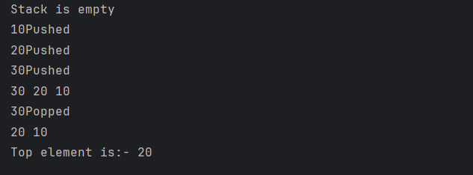

Stack using Collection:-

import java.util.Stack;
Stack<Integer> stack = new Stack<>();

Method:
1]push(value):-Add element to stack.
2]pop():- Remove element from top.
3]peek():- View top element;
4]isEmpry():- Check stack is empty or not.
5]search():-Position from top.

package JavaPraticeProgram.CommandLineExample.DSA.Stack;

import java.util.Stack;

public class StackUsingLinkedList {
public static void main(String[] args) {
Stack<Integer> stack = new Stack<>();

stack.push(10);
stack.push(20);
stack.push(30);

System.out.println(stack);
System.out.println(stack.peek());

stack.pop();
System.out.println(stack);
}
}

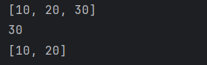

Lecture 12: Queue
Queue is a linear data structure which use FIFO.
FIFO(First In First Out).

Queue using array.

package JavaPraticeProgram.CommandLineExample.DSA.Queue.QueueUsingArray;
public class QueueUsingArray {
int [] queue ;
int front , rear , size;
QueueUsingArray(int size){
this.size = size;
queue = new int[size];
front = -1;
rear = -1;
}

void push(int data){
if(rear == size-1){
System.out.println("Queue is full");
return;
}

if(front == -1){
front = 0 ;
}
rear++;
queue[rear] = data;
System.out.println("Element add"+data);
}

void pop(){
if(front == -1){
System.out.println("Queue is empty");
return;
}
System.out.println("Deleted element is "+queue[front]);
front++;
}
void peek(){
if(front == -1){
System.out.println("Queue is empty");
return;
}
System.out.println("Front element is "+queue[front]);
}
void display(){
if(front == -1){
System.out.println("Queue is empty");
return;
}
for(int i = front ; i<=rear;i++){
System.out.print(queue[i]+" ");
}
System.out.println();
}

}

package JavaPraticeProgram.CommandLineExample.DSA.Queue.QueueUsingArray;

public class Imp {
public static void main(String[] args) {
QueueUsingArray qe = new QueueUsingArray(5);

qe.push(10);
qe.push(20);
qe.push(30);
qe.push(40);
System.out.println("Element in queue");
qe.display();

qe.pop();
System.out.println("element in queue");
qe.display();

qe.peek();

}
}

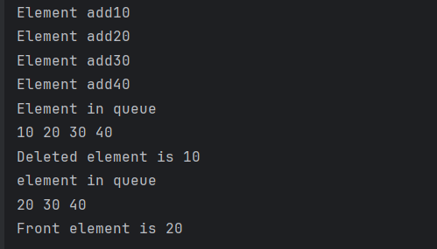

Stack using Linked list.
package JavaPraticeProgram.CommandLineExample.DSA.Queue.QueueUsingLinkedlist;

class Node{
int data;
Node next;

Node(int data){
this.data = data;
this.next = null;
}
}
public class QueueUsingLinkedlist {

Node head , tail;

boolean isEmpty(){
return head == null;
}

void push(int data){
Node newNode = new Node(data);

if(isEmpty()){
head = tail = newNode;
return;
}
tail.next = newNode;
tail = newNode;
}

void pop(){
if(isEmpty()){
System.out.println("Queue is empty");
return;
}
System.out.println("Deleted element is:-"+head.data);
head = head.next;
}

void front(){
if(isEmpty()){
System.out.println("Queue is empty");
return;
}
System.out.println("Element at front is:-"+head.data);
}

void display(){
if(isEmpty()){
System.out.println("Queue is empty");
return;
}
Node temp = head;
while (temp != null){
System.out.print(temp.data+"->");
temp = temp.next;
}
System.out.println("null");
}

}

package JavaPraticeProgram.CommandLineExample.DSA.Queue.QueueUsingLinkedlist;

public class QueueUsingLinkedlistImp {
public static void main(String[] args) {
QueueUsingLinkedlist queueUsingLinkedlist = new QueueUsingLinkedlist();
queueUsingLinkedlist.display();

System.out.println("Element add to queue");
queueUsingLinkedlist.push(10);
queueUsingLinkedlist.push(20);
queueUsingLinkedlist.push(30);
queueUsingLinkedlist.push(40);
queueUsingLinkedlist.display();

System.out.println("Element remove from queue");
queueUsingLinkedlist.pop();
queueUsingLinkedlist.display();

queueUsingLinkedlist.front();

}
}

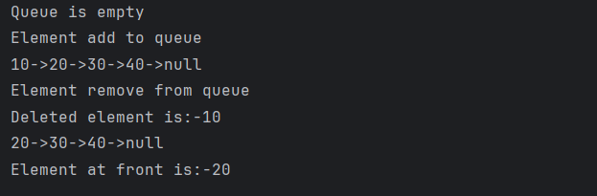

Using a collection frame.
package JavaPraticeProgram.CommandLineExample.DSA.Queue.QueueUsingLinkedlist;

import java.util.LinkedList;
import java.util.Queue;

public class UsingCollection {
public static void main(String[] args) {
Queue<Integer> queue = new LinkedList<>();

System.out.println("Add element add to queue");
queue.add(10);
queue.offer(20);
queue.add(30);
queue.add(40);
queue.add(50);

System.out.println("Element in queue"+queue);

System.out.println("Remove element from front using remove:-"+queue.remove());
System.out.println("Remove element from front using poll:-"+queue.poll());

System.out.println("Element in queue"+queue);

System.out.println("Peek front element using element:-"+queue.element());
System.out.println("Peek front element using peek:-"+queue.peek());

System.out.println("Check queue is empty or not:-"+queue.isEmpty());
System.out.println("Check element 40 exist in queue or not:-"+queue.contains(40));
System.out.println("Size od queue:-"+queue.size());

}
}
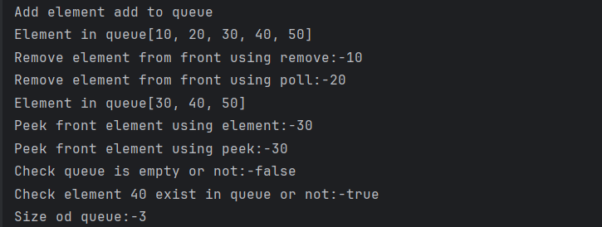
Priority Queue:-A Priority Queue is a special type of queue where elements are processed based on priority, not insertion order.

Smallest element has highest priority.

package JavaPraticeProgram.CommandLineExample.DSA.Queue.PriorityQueue;

import java.util.Collection;
import java.util.Collections;
import java.util.PriorityQueue;

public class PriorityQueue1 {
public static void main(String[] args) {
// Accourding to small value
PriorityQueue<Integer> queue = new PriorityQueue<>();
// Accourding to high value
// PriorityQueue<Integer> queue = new PriorityQueue<>(Collections.reverseOrder());

queue.add(10);
queue.add(50);
queue.add(30);
queue.add(40);
queue.add(20);

System.out.println(queue);

System.out.println(queue.remove());
System.out.println(queue);

System.out.println(queue.peek());
}
}

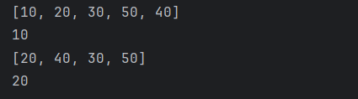

Circular Queue:-A Circular Queue is a queue where:
- Last position connects back to the first
- Saves memory by reusing empty spaces
Circular queue using array.
package JavaPraticeProgram.CommandLineExample.DSA.Queue.CircularQueue;
public class CircularQueueArray {
int[] queue;
int size , front , rear;
CircularQueueArray(int size){
this.size = size;
queue = new int[size];
front = -1;
rear = -1;
}
boolean isFull(){
return ((front == 0 && rear == size - 1)|| front == rear +1 );
}
boolean isEmpty(){
return front == -1;
}
void enqueue(int data){
if(isFull()){
System.out.println("Queue is full");
return;
}
if(front == -1){
front = rear = 0;
}else if(rear == size -1 && front != 0){
rear = 0;
}else {
rear ++;
}
queue[rear] = data;
System.out.println("Inserted element is:- "+data);
}
void dequeue(){
if(isEmpty()){
System.out.println("Queue is empty");
return;
}
System.out.println("Deleted: " + queue[front]);
if(front == rear){
front = rear = -1;
}else if(front == size-1){
front = 0;
}else {
front ++;
}
}
void peek(){
if(isEmpty()){
System.out.println("Queue is empty");
return;
}else {
System.out.println("Element at front"+queue[front]);
}
}

void display(){
if (isEmpty()) {
System.out.println("Queue is Empty");
return;
}
System.out.print("Circular Queue: ");
int i = front;
while (true){
System.out.print(queue[i]+" ");
if(i == rear)
break;
i= (i+1)%size;
}
System.out.println();
}
}
package JavaPraticeProgram.CommandLineExample.DSA.Queue.CircularQueue;

public class Imp {
public static void main(String[] args) {
CircularQueueArray cq = new CircularQueueArray(5);

cq.enqueue(10);
cq.enqueue(20);
cq.enqueue(30);
cq.enqueue(40);
cq.enqueue(50);

cq.display();

cq.dequeue();
cq.enqueue(60);
cq.display();
cq.peek();

}
}

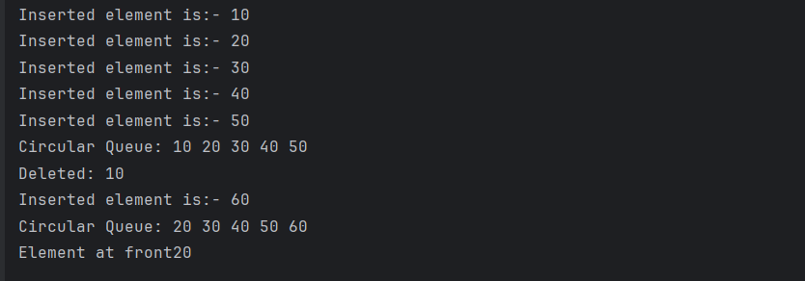

Circular queue using Linked list.
package JavaPraticeProgram.CommandLineExample.DSA.Queue.CircularQueue;
class Node{
int data;
Node next;

Node(int data){
this.data = data;
this.next = null;
}
}
public class CircularQueueUsingLinkedList {
Node front, rear;

boolean isEmpty(){
return front == null;
}

void enqueue(int data){
Node newNode = new Node(data);

if(isEmpty()){
front = rear = newNode;
rear.next = front;
}else{
rear.next = newNode;
rear = newNode;
rear.next = front;
}
System.out.println("Inserted element is:-"+data);
}
void dequeue(){
if(isEmpty()){
System.out.println("Queue is empty");
return;
}
if(front == rear){
System.out.println("Deleted:-"+front.data);
front = rear = null;
}else{
System.out.println("Deleted:-"+front.data);
front = front.next;
rear.next = front;
}
}
void peek(){
if(isEmpty()){
System.out.println("Queue is empty");
return;
}else{
System.out.println("Element at front is:-"+front.data);
}
}
void display(){
if(isEmpty()){
System.out.println("Queue is empty");
return;
}
System.out.print("Circular Queue: ");
Node temp = front;
do{
System.out.print(temp.data+" ");
temp = temp.next;
}while (temp != front);
System.out.println();
}
}

package JavaPraticeProgram.CommandLineExample.DSA.Queue.CircularQueue;

public class CircularQueueUsingLinkedListImp {
public static void main(String[] args) {
CircularQueueUsingLinkedList cq = new CircularQueueUsingLinkedList();
cq.enqueue(10);
cq.enqueue(20);
cq.enqueue(30);
cq.enqueue(40);
cq.enqueue(50);
cq.display();
cq.dequeue();
cq.enqueue(10);
cq.display();
}
}

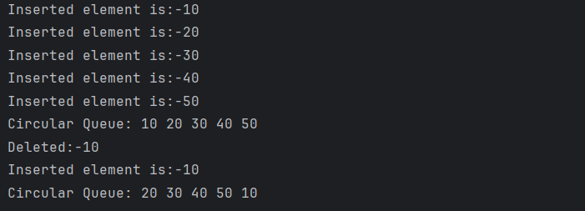

Using Collection frame work.

package JavaPraticeProgram.CommandLineExample.DSA.Queue.CircularQueue;

import java.util.ArrayDeque;
import java.util.Queue;

public class CircularLinkedUsingCollection {
public static void main(String[] args) {

Queue<Integer> cq = new ArrayDeque<>();

cq.offer(10);
cq.offer(20);
cq.offer(30);
cq.offer(40);

System.out.println(cq); // [10, 20, 30, 40]

cq.poll(); // removes 10
cq.poll(); // removes 20

cq.offer(50);
cq.offer(60);

System.out.println(cq); // [30, 40, 50, 60]
}
}

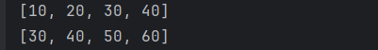

Lecture 13: Hash Table, HashMap and Hash Sets

Hashing is a technique used to store and retrieve data quickly using a key.
- A hash function converts a key into an index.
- The value is stored at that index in a table

This makes search, insert, and delete operations very fast.

Hash Function: - h(k) = k%10;
K=represent value (ex-roll number)

Ex: - Roll Number = 3457843

Hask key h(k) = 3457843 % 10 = 3

Hash key = 3

Collision: - When two or more keys map to the same index it’s called collision.

To solve collision by using two techniques.
1]Separate chaining or open hashing.
2]Open addressing or closed hashing.

Separate Chaining (Open Hashing)
- Each index (bucket) of the hash table stores a Linked List
- Multiple elements can exist at the same index
How it works
- Hash function gives an index
- If bucket is empty → insert element
- If bucket already has elements → add new element to linked list

Open Addressing (Closed Hashing)
- All elements are stored inside the hash table itself
- If collision occurs → search for another empty index

If collision occurs search for another empty index this process called probing.

Probing techniques: -
- Linear Probing
- Quadratic Probing
- Double Hashing

- 1] Linear Probing: - In general, you generate the probe sequence using the function
  - hi(key) = [h(key) + a*i] % m
  - where ‘m’ is the table size and ‘i’ ranges from 0 to m-1.
Ex:-Hash table size 13 a=1

 |  | 41 |  |  | 18 | 44 | 59 | 32 | 22 | 31 | 73
0 1 2 3 4 5 6 7 8 9 10 11 12
Insert(18)= [18+1*0]%13 = 5 insert(44)=5+1 insert(31)=5+5=10
Insert(41)= [41+1*0]%13 = 2 insert(59)=7 insert(73)=8+3=11
Insert(22)= [22+1*0]%13 = 9 insert(32)=6+1+1
Linear Probing drawbacks: - Linear probing is also prone to primary cluster formation. A cluster is a group of contiguous hash table entries, which occurs when keys hash to values close to one another

2] Quadratic Probing:-
  - [h(key) + a*i^2 ] % m

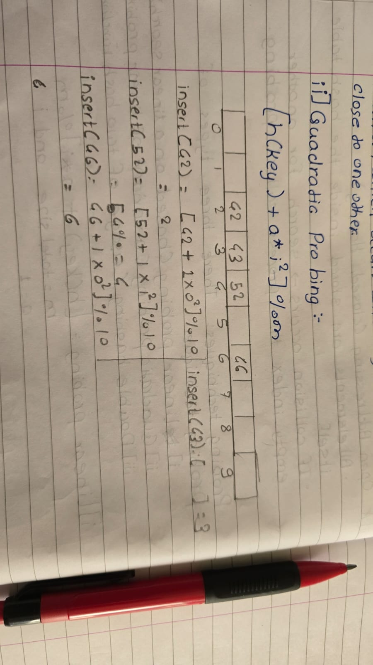

Quadratic probing performs much better than linear probing because it does not lead to the formation of clusters because keys hash to nearby values. However, it leads to the formation of clusters because of keys hashing to identical values. These clusters are known as secondary clusters.

3] Double Hashing: - [h(key) + i*h_{second}(key)] % m

Ex:- key % 13 h_{second}(key)
Second hash function:- 7 – key % 7
Keys to be inserted: 18, 26, 35, 9, 64, 47, 96, 36 and 70.

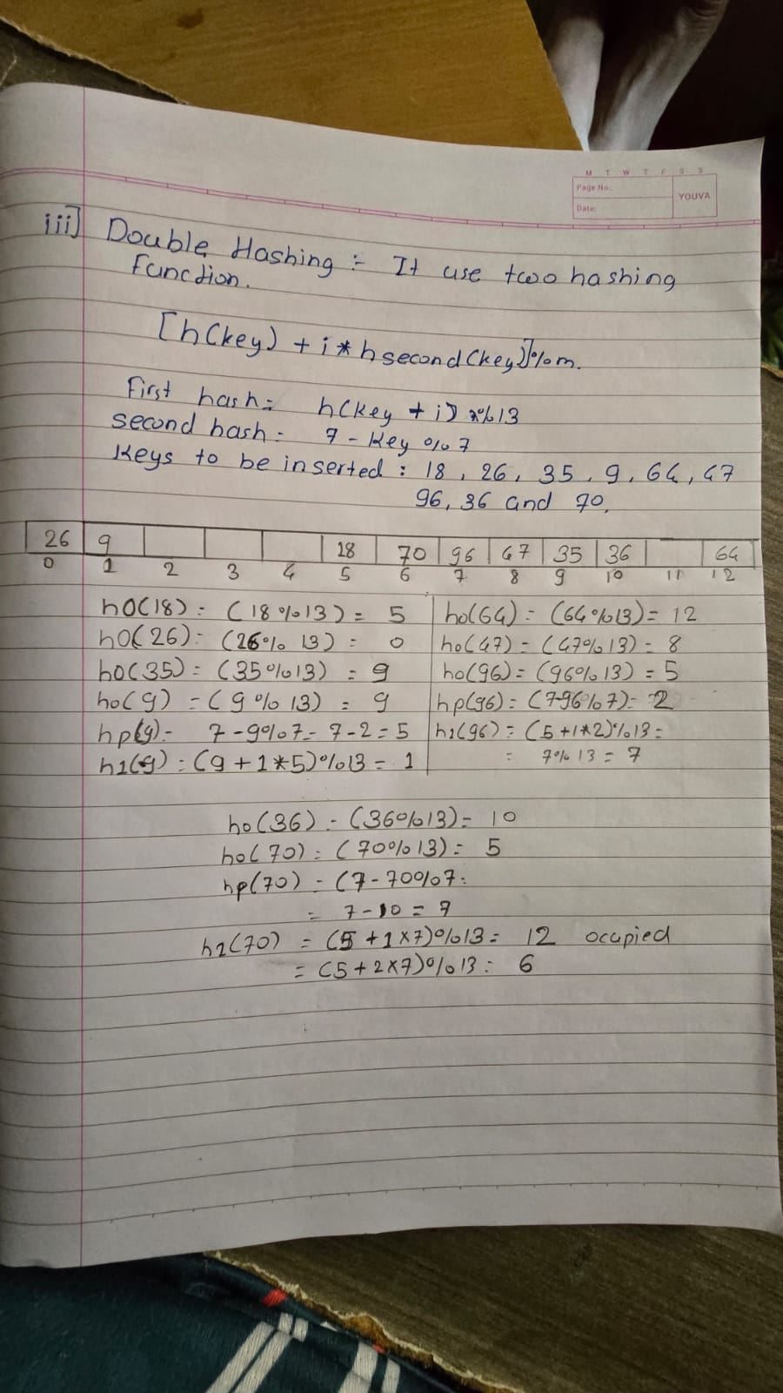

Hash Table:- Hashtable is a Map-based data structure in Java used to store data in the form of (key , value).

Feature: Data store in Key-Value pair , Duplicate Keys not allowed , Duplicate Values are allowed , Null Key and value are not allowed.

Method | Purpose
put(key,value) | Insert data
get(key) | Retrieve value
remove(key) | Delete entry
containsKey() | Check key
containsValue() | Check value
size() | Total entries
keySet() | Get all keys
values() | Get all values
entrySet() | Key–value pair
clear() | Remove all data

Implementation
package JavaPraticeProgram.CommandLineExample.DSA.Hash.HashTable;
import java.util.Collection;
import java.util.HashSet;
import java.util.Hashtable;
import java.util.Set;
public class FiestProgram {
public static void main(String[] args) {
Hashtable<Integer , Integer> hashtable = new Hashtable<>();
System.out.println("Insert element in hash table");
hashtable.put(1,10);
hashtable.put(2,20);
hashtable.put(3,30);
hashtable.put(4,40);
hashtable.put(5,50);
System.out.println("Element in hashtable:-"+hashtable);
System.out.println("Value at key 3:-"+hashtable.get(3));
System.out.println("After remove element at index 4:-"+hashtable.remove(4));
System.out.println("Element in hashtable:-"+hashtable);
System.out.println("Contains key 2?:-"+hashtable.containsKey(2));
System.out.println("Contains value 10?"+hashtable.containsValue(10));
System.out.println("Size: " + hashtable.size());
Set<Integer> keys = hashtable.keySet();
System.out.println("Keys: " + keys);
Collection<Integer> values = hashtable.values();
System.out.println("Values: " + values);
// Type casting is done in this process because hashtable.clone()
// In the form of object we need to convert it into hashtable
Hashtable<Integer , Integer> set2 = (Hashtable<Integer, Integer>) hashtable.clone();
System.out.println(set2);
}
}

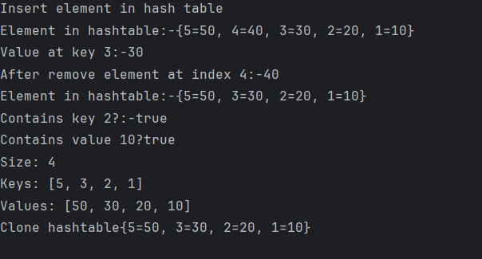

Find pair with the given sum in an array(Two Sum)
We have already solved this problem using different approach. Here we will try to solve using Hashtable

package JavaPraticeProgram.CommandLineExample.DSA.Hash.HashTable;
import java.util.Hashtable;
public class TwoSum {
public static void main(String[] args) {
Hashtable<Integer , Integer> ht = new Hashtable<>();
int[] arr = {10,30,40,20,50};
int k = 30;
for(int num : arr){
int sum = k-num;
if(ht.containsKey(sum)){
System.out.println(sum+" "+num);
}
ht.put(num,1);
}
}
}


HashMap:- HashMap is a collection class in Java used to store data as key -> value.

Kay features of hash map:
Store in key value pair, do not allow duplicate key but stored duplicate value. Allow to stored null value and key.

Methods
put (key, value):- Add or update data
get(key): - Get value using key
remove(key): - Remove entry
containsKey(key): - Check if key exists
containsValue(value): - Check if value exists
size(): - Number of entries
isEmpty(): - Check map is empty or not
keySet(): - Get all keys
values(): - Get all values
entrySet(): - Get key + value together
clear(): - Remove all entries

Implementation:
package JavaPraticeProgram.CommandLineExample.DSA.Hash.HashMap;
import java.util.HashMap;
public class FirstProgram {
public static void main(String[] args) {
HashMap<Integer , Integer>hashMap = new HashMap<>();
hashMap.put(1,10);
hashMap.put(2,20);
hashMap.put(3,30);
hashMap.put(4,20);
hashMap.put(5,50);
System.out.println(hashMap);
System.out.println(hashMap.get(2));
System.out.println(hashMap.containsKey(4));
System.out.println(hashMap.containsValue(20));
System.out.println(hashMap.size());
for(var num : hashMap.entrySet() ){
System.out.println(num.getKey()+"-->"+num.getValue());
}
}
}

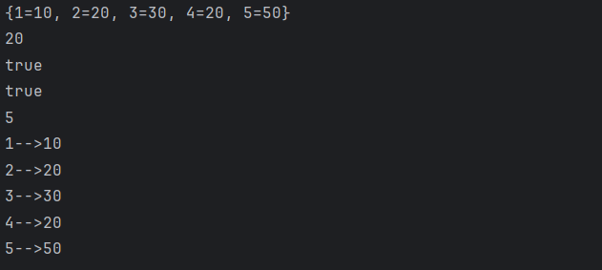

Hash set: - HashSet is a collection class in Java used to store a group of unique elements.

Key Features: -
No duplicates allowed
No index (no position)
Order is not guaranteed
Method
add(element)
remove(element)
contains(element)
size()
isEmpty()
clear()
package JavaPraticeProgram.CommandLineExample.DSA.Hash.HashSet;
import java.util.HashSet;
public class FirstProgram {
public static void main(String[] args) {
HashSet<Integer>hs = new HashSet<>();
hs.add(10);
hs.add(20);
hs.add(30);
System.out.println(hs);
System.out.println("Element present or not:-"+hs.contains(30));
System.out.println("Remove element:-"+hs.remove(10));
System.out.println(hs.size());
System.out.println(hs);
}
}

